Introduction to Computer Science – D684

Section 5

Lesson 1

* 1. **– Computing Components**

**The 5 Components of the von Neumann architecture**

|  |  |  |
| --- | --- | --- |
| Component | Description | Additional Concepts |
| **Memory Unit** | Holds data and instructions for processing. Determines **addressability** (the number of bits used to access memory locations) | **Cache Memory** – A small, fast memory storing frequently used data for quick access |
| **Arithmetic/Logic Unit (ALU)** | Performs arithmetic and logic operations on data. Uses **registers** for temporary storage of data during calculations | **Pipelining** – Allows overlapping instruction execution for increased efficiency |
| **Input Unit** | Moves data from external sources into the computer | Includes devices like keyboards, mice, and scanners |
| **Output Unit** | Moves processed data and results from the computer to the outside world | Includes monitors, printers, and speakers |
| **Control Unit** | Directs and coordinates all components to ensure smooth operation.  Uses the **Instruction Register (IR)** to store the current instruction and the **Program Counter (PC)** to track execution order | **Motherboard** – The main circuit board that connects all components, ensuring communication between them  **Bus Width** – Determines how much data can be transferred at a time, impacting overall system speed |

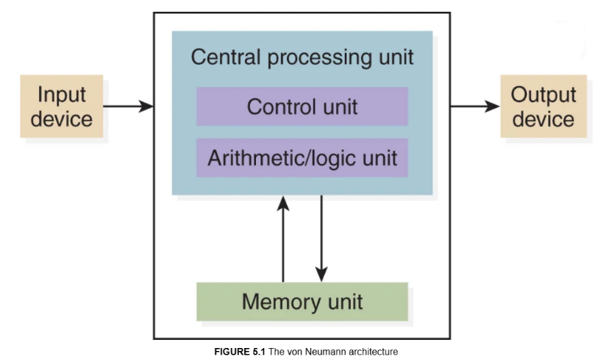Figure 5.1 from page 125, Computer Science Illuminate

**Fetch-execute cycle** = the process by which a computer retrieves and executes instructions. It consists of **four steps**:

1. **Fetch the Next Instruction** – The CPU retrieves the next instruction from memory using the Program Counter (PC).
2. **Decode the Instruction** – The instruction is interpreted by the Control Unit to determine the necessary operation.
3. **Get Data if Needed** – If the instruction requires data, it is fetched from memory or input devices.
4. **Execute the Instruction** – The CPU carries out the instruction, which may involve calculations, moving data, or controlling output.

**RAM vs ROM**

|  |  |  |
| --- | --- | --- |
| Feature | **RAM (Random Access Memory)** | **ROM (Read-Only Memory)** |
| Function | Stores data and programs actively in use | Stores firmware and essential startup instructions |
| Volatility | Volatile – data is lost when power is off | Non-volatile – retains data even when power is off |
| Modifiability | Read and write memory (data can be changed) | Typically read-only; modifications require special processes |
| Speed | Fast access time for active processes | Slower than RAM but faster than secondary storage |
| Example Uses | Running applications, temporary file storage | BIOS firmware, embedded system software |

**Secondary Storage Devices**

|  |  |  |  |
| --- | --- | --- | --- |
| Storage Device | Description | Strengths | Weaknesses |
| Magnetic Tape | Sequential storage device using a reel of tape for data storage. Often used for backups and archiving | - High capacity  - Inexpensive per GB  - Long-term data retention | - Slow access speed (sequential access)  - Not ideal for frequent data retrieval |
| Magnetic Disk | Uses magnetized platters to store and retrieve data via read/write heads. Basis for HDDs | - Faster access than tape  - Can be rewritten many times  - Reliable for everyday use | - Mechanical parts can fail  - Slower than SSDs |
| Hard Disk Drive (HDD) | A type of magnetic disk storage with rotating platters. Commonly used in computers for bulk storage | - High storage capacity  - Cost-effective per GB  - Can last many years with proper care | - Slower than SSDs  - Prone to physical damage due to moving parts |
| Solid-State Drive (SSD) | Uses flash memory for storage, with no moving parts, leading to faster speeds and reliability | - Very fast data access  - More durable (no moving parts)  - Energy efficient | - More expensive per GB than HDDs  - Limited write cycles (though modern SSDs have improved durability) |
| Flash Drive (USB Drive) | Portable solid-state storage using flash memory, typically connected via USB | - Highly portable  - Fast read/write speeds  - No moving parts (durable) | - Limited capacity compared to SSDs/HDDs  - Can be lost easily due to small size |
| CDs/DVDs | Optical discs used for data storage, multimedia, and backups. CDs store up to 700MB, DVDs up to 4.7GB (single-layer) | - Cheap and widely available  - Good for long-term storage if kept in proper conditions | - Prone to scratches and degradation  - Limited storage capacity compared to modern alternatives |

Lesson 2

**2.1– Networking Architecture and Technologies**

**Key Terms**

|  |  |
| --- | --- |
| **Term** | **Definition** |
| **Computer Network** | A collection of interconnected devices (computers, printers, etc.) that communicate and share resources |
| **Node** | Any device on a network (e.g., computer, printer, router) |
| **Host** | A computer or device on a network that provides services or resources to other devices |
| **Data Transfer Rate** | The actual speed at which data is successfully transmitted (measured in Mbps, Gbps, etc.) |
| **Bandwidth** | The maximum amount of data that can be transferred over a network in a given time |
| **Client-Server Model** | A network model where clients request services and servers provide them (e.g., websites, file servers) |
| **Peer-to-Peer Model (P2P Model)** | A network model where devices communicate directly and share resources without a centralized server |
| **Latency** | The delay between sending and receiving data |
| **Firewall** | Security system that monitors and controls incoming and outgoing network traffic based on predetermined security rules |

**LAN vs WAN vs MAN**

|  |  |  |  |
| --- | --- | --- | --- |
| Network Type | Topology  /Subtype | Description | Figure |
| **LAN (Local Area Network)** | See below | Connects computers within a limited area like a home, school, or office | See below |
|  | Ring | Each device connects to two others, forming a circle. Data travels in one direction |  |
| Star | All devices connect to a central hub or switch |  |
| Bus | All devices share a single communication line (the bus) |  |
| **WAN (Wide Area Network)** |  | Covers a broad area (multiple cities, countries); connects multiple LANs | - |
| **MAN (Metropolitan Area Network)** |  | Spans a city or large campus; larger than LAN but smaller than WAN | - |

**Packet** = A unit of data and control information for routing that is sent across a network

**Packet Switching** = a method of data transmission where messages are broken into smaller units called **packets**. Each packet is sent independently over the network and may take different paths to reach the destination. Once all packets arrive, they are reassembled into the original message

**Open System** = a system based on publicly available standards that can interact with other systems, regardless of vendor or platform.

**Protocol** = a set of rules that govern data communication between devices in a network

**Protocol Stack** = a set of network protocol layers that work together to handle the transmission of data over a network. Each layer in the stack performs a specific function and interacts with the layers directly above and below it.

**OSI Model** = is a conceptual framework that standardizes network communication functions into **7 distinct layers:**

|  |  |  |
| --- | --- | --- |
| Layer (Top to Bottom) | Layer Name | Function |
| 7 | Application | Interface for user applications (e.g., email, browsers) |
| 6 | Presentation | Translates data formats, encryption/decryption |
| 5 | Session | Manages sessions and controls dialog between computers  -establishing, managing, and terminating connections between applications |
| 4 | Transport | Ensures reliable data delivery (e.g., TCP) |
| 3 | Network | Determines data path/routing (e.g., IP) |
| 2 | Data Link | Manages node-to-node communication and error checking |
| 1 | Physical | Transmits raw bits over physical medium (e.g., cables, radio signals) |

**TCP/IP** = is a **specific protocol stack** used on the Internet, organizing protocols into 4 layers (Application, Transport, Internet, Link)

TCP (Transmission Control Protocol) = ensures reliable transmission of data over the internet

**High-Level Protocols** = operate at the Application layer. They rely on lower-layer protocols (e.g., TCP/IP) for actual data delivery

**Key High-Level Protocols**

|  |  |
| --- | --- |
| Protocol Name | Description |
| SMTP (Simple Mail Transfer Protocol) | Specifies the transfer of electronic mail |
| FTP (File Transfer Protocol) | Allows a user on one computer to transfer files to and from another computer |
| Telnet | Used to log into a computer system from a remote computer |
| HTTP (Hypertext Transfer Protocol) | Defines the exchange of world wide web documents which are usually written in HTML |

**Network Addresses**

|  |  |  |
| --- | --- | --- |
| Term | Definition | Example |
| Hostname | A human-readable label assigned to a device on a network. It identifies a specific computer or service within a domain | www.example.com |
| IP Address | A unique numerical identifier assigned to each device connected to a network, typically written in either IPv4 or IPv6. It is used for routing data between devices. | IPv4 (32 bits):  192.168.1.1  IPv6 (128 bits): FE80:0000:0000:0000:0202:B3FF:FE1E:8329 |

**Domain Name System (DNS) and Key Terms**

|  |  |
| --- | --- |
| Term | Definition |
| Domain Name | A readable address used to identify a location on the internet (e.g., example.com). It consists of two parts: a second-level domain and a top-level domain (TLD). |
| Top-Level Domain (TLD) | The final segment of a domain name, located after the last dot (e.g., .com, .org, .net). It specifies the type or category of the domain. |
| ICANN (Internet Corporation for Assigned Names and Numbers) | A non-profit organization responsible for coordinating and managing the global Domain Name System (DNS) and IP address allocation |
| Domain Squatting | The practice of registering domain names with the intent to sell them at a higher price to the legitimate owner of the name |
| Domain Name System (DNS) | A hierarchical system that translates human-readable domain names (e.g., www.example.com) into machine-readable IP addresses (e.g., 192.168.1.1) |
| Domain Name Servers (DNS Servers) | Servers that store domain names and their corresponding IP addresses, enabling the translation from a domain name to an IP address when requested |
| Network Neutrality | The principle that all internet traffic should be treated equally, without discrimination or charging differently based on the user, content, website, platform, or application |

Figure 15.11 from page 511, Computer Science Illuminated

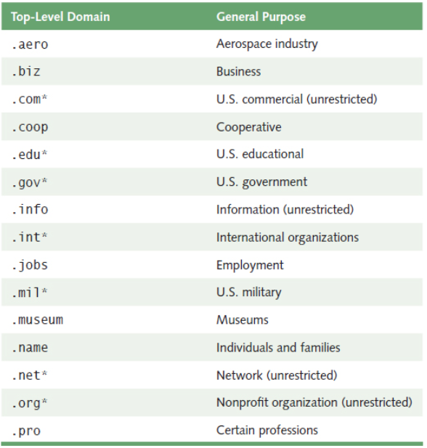

Lesson

**3.1– Other Computing Devices and the Internet of Things**

|  |  |  |
| --- | --- | --- |
| **Term** | **Definition** | **Example** |
| **Internet of Things (IoT)** | A network of physical devices (like sensors, vehicles, appliances, etc.) connected to the internet, allowing data exchange | Smart thermostats (e.g., Nest), connected refrigerators, smartwatches, ring doorbell |
| **Server** | A computer or system that provides services, resources, or data to other computers (clients) over a network | Web server, email server, file server |
| **Server Farm** | A collection of servers housed together in a facility, providing large-scale services like hosting or data processing | Amazon Web Services (AWS) data centers, Google Cloud data centers |
| **PC/Desktop** | A personal computer designed for regular use, typically sitting on a desk with separate components (monitor, keyboard) | Dell XPS desktop, Apple iMac |
| **Laptop** | A portable personal computer that combines all components in a single device, designed for mobility | MacBook Air, Dell XPS 13 |
| **Tablet** | A portable touchscreen device, typically smaller than a laptop, used for browsing, apps, and media consumption | iPad, Samsung Galaxy Tab |
| **Smartphone** | A handheld device that combines a mobile phone with a computer, offering internet access, apps, and multimedia | iPhone, Samsung Galaxy S |
| **Mainframe** | A large, powerful computer used primarily by organizations for bulk data processing, transaction handling, and storage | IBM Z series mainframe |
| **Supercomputer** | Extremely powerful computers used for complex computations like simulations, scientific research, and weather modeling | Fugaku (Japan), Summit (USA) |
| **Embedded Computer** | A specialized computer designed to perform dedicated functions within a larger system, often with real-time constraints | Car engine control system, smart thermostat, microwave controller |